Fine and Contemporary Dining |  |  |  |  |  |  |  | Restaurant and Café Dining
Sydney edition  (the best of the city, east,  south and inner west)  • Cafe Sydney  • Bilsons  • Restaurant Balzac  • 3 Weeds, The Restaurant  • Astral  • Sugaroom  • Spice I Am  • Ocean Room  • The Riverview Hotel  • Foveaux Restaurant + Bar  • Restaurant Assiette  • Manta  • Nino’s Hideaway  • Nick’s Restaurants + I’m Angus  • Wolfies / Waterfront / Italian Village  • The Light Brigade  • Blancharu  and many more... |  | Sydney North edition  (the best of the upper and lower  north shores and northern beaches  • Pilu at Freshwater  • Public Dining Room  • Whitewater  • Milson’s  • The Bathers’ Pavilion  • La Grillade  • Terrace on Pittwater  • Orso Bayside Restaurant  • Berowra Waters Inn  • Clareville Kiosk  • Limani Seafood Restaurant  • Nilgiri’s  • Ormeggio  • Sails On Lavender Bay  • Fiorenzoni  • Food & Plonk  • Koi  and many more... |  |  |  |  | Sydney edition  (the best of the city, east,  south and inner west)  • Tony Roma’s  • Wagamama  • Din Tai Fung  • Red Chilli Scichuan  • Thai Riffic  • Blackbird Café  • Miss Saigon  • Le Pain Quotidien  • Mike’s Grill and Bar  • Sauce Bar & Grill – Coogee  • Trio – Bondi  • Essen  • In the Mood for Thai  • Bondi Tucker  • Govinda’s  • Pancakes on The Rocks  • Cafe Morso  and many more... |  |  | Sydney North edition  (the best of the upper and lower  north shores and northern beaches  • PJ Gallagher’s  • The Narrabeen Sands Hotel  • Pecorino  • Wood and Stone  • 4 Pines Brewing Company Restaurant  • Chill Seafood  • Stir Crazy Thai  • The Newport Arms  • Flying Fox Café  • Hit Cafe  • Le Bistro at The Union Hotel  • Food I love  • The Belrose Hotel  • Wok on Inn  • Mezzo Matto  • Bar Asia  • Olive Bar & Grill  and many more...
The following appear in both the Sydney and Sydney North editions.
Informal Dining and  Takeaway Restaurants  • McDonald’s  • Gloria Jean’s Coffees  • Michels Pattiserie  • Hungry Jack’s  • Domino’s Pizza  • Oporto  • Krispy Kreme  • Subway  • Pie Face  • New Zealand Natural  • Ogalo Portuguese Chicken  • Gelatissimo  • Doughboy and many more... |  |  | Arts, Sports  and Attractions  • Hoyts  • Taronga Zoo  • Greater Union (Event Cinemas)  • Sydney Aquarium  • IMAX  • Sydney Symphony  • Luna Park  • Sydney Wildlife World  • Sydney Theatre Company  • Sydney Tower Skywalk  • Sydney Swans  • The Australian Ballet  • NSW Waratahs and many more... |  |  |  |  | Retail, Travel, Leisure and Accommodation  • Avis/Budget/Europcar/Hertz/Thrifty • Mantra/BreakFree Hotels Resorts  • Hamilton Island & Apartments  • QBE Travel Insurance • Warner Village Theme Parks  • Fantasea Cruises • Dreamworld/Whitewater World  • Conrad Jupiters • Couran Cove Island Resort  • ACP/News/Pacific Magazines and many more...  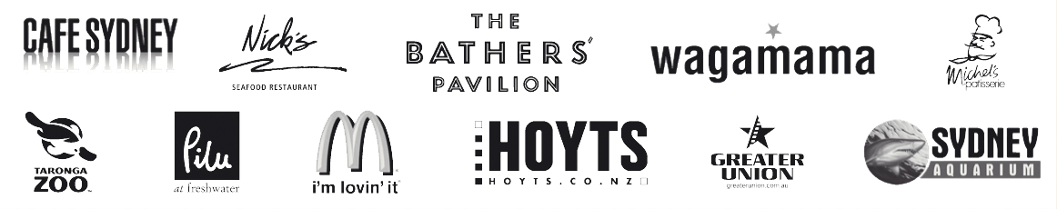
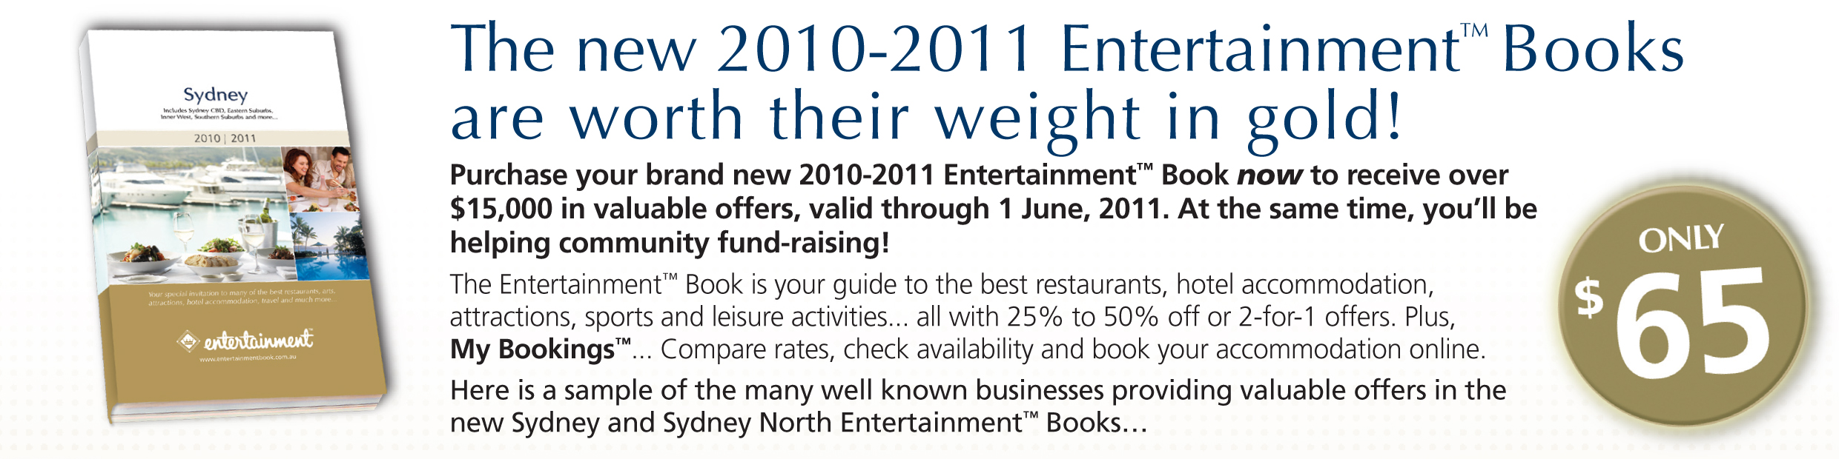
For a complete listing of participating businesses or more information about Entertainment™ Books for other cities, please visit www.entertainmentbook.com.au.
To purchase your new Entertainment™ Book, contact:

UNSW Tennis Club
Lucy Hermanto|0425152222 |lucy_hermanto@hotmail.com
Marvin Yudo|0408328888 |marvin.pcw.y@gmail.com

Name:_______________________________ Daytime Phone: __ __ __ __ __ __ __ __ __ __ Address:________________________________________________
__________________________________________________________________________Suburb___________________________P/Code:_____________________
Edition required: _____ x Sydney @ $65 each $_______________(GST Inc.)
_____ x Sydney North @ $65 each $_______________(GST Inc.)
_____ x Parramatta @ $60 each $_______________(GST Inc.)

Total amount enclosed: $_______________(GST Inc.)
Method of payment: q Cash or please charge my: q Master Card qVisa
Credit Card No.: ___ ___ ___ ___/___ ___ ___ ___/___ ___ ___ ___/___ ___ ___ ___ Expiry Date: __ ___/___ ___
Cardholder’s Name (print clearly) : _________________________________ ___________Signature_________________________________________________
20% for every Book sold goes towards our fundraising – Thank you for your support!
For Editions in other locations, please contact: Lucy Hermanto 0425 152222, Marvin Yudo 0408 328888

